April 1 – Bill Lansdell
April 4 – Renee Garcia
April 6 – Jan Mitchell
April 8 – Linda Smith
April 8 – Shawna Tucker
April 8 – Julie Armstrong
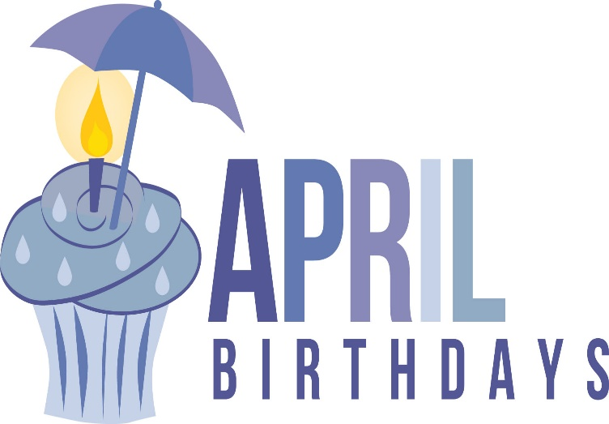
April 10 – Marsha Taylor
April 14 – Austin Kelly-Karney
April 16 – Valerie Hernandez
April 17 – Hunter Romero
April 17 – Rylan Green
April 18 – Barbara Springer
April 18 – Makayla Christopher
April 19 – Ryan Honeyfield
April 19 – Josiah Navarro
April 19 – Oliver Hemphill
April 20 – Mike Hinders
April 21 – Billie Joe Winchester
April 21 – Karen Bonanno
April 21 – Nick Christopher
April 21 – Autumn Valigura
April 22 – Marietta Wright
April 23 – Shelby Eubank
April 25 – Regina Janke
April 29 – Margrace Grotefend
April 30 – Bruce Walters

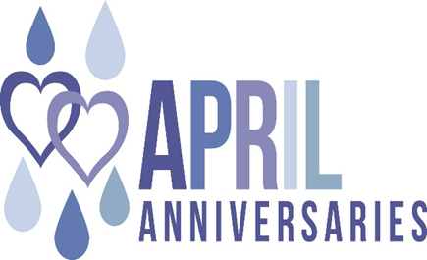
April 14 – Bill & Margrace Grotefend
April 21 – Jerry & Patti Thompson
April 22 – Steve & Angie Davis
April 27 – Gilbert & Carole Row

